Final Analysis Program

Imaging team

**Start Date:** October 14, 2014

**Due Date:** November 25,2014

**Participants & Roles:**

Avery Berchek C++, Field Isolation Algorithm

Francis Espiritu Java Conversion of C++, Field Isolation Algorithm

Patrick Thavornkant Java Conversion of C++, Field Isolation Algorithm

**Introduction:** The aim of this program is to be able to take stitched images and to isolate fields within those images. The purpose of doing this is to allow us to combine this program with our crop-field image analysis programs.

**Deliverable:** The program takes a stitched image of a crop field within its surroundings, runs it through the giant program. After the program completes, it spits out that same stitched image with the pixels corresponding to the bad parts of the crop yellow.

**What It Does:** The program takes a stitched image of a crop field within its surroundings, runs it through the giant program. After the program completes, it spits out that same stitched image with the pixels corresponding to the bad parts of the crop yellow.

**How It Works:** The program starts off with a preset range of HSV values and a stitched image that it is supposed to run through. It then converts the stitched image to an HSV image and iterates through all the pixels to see if their given HSV value is within that original preset range. It creates a new matrix and if that pixel it is comparing is within that range then it turns the corresponding pixel in that new matrix white. If it is outside that range then it turns the pixel black. After it completes that, it iterates through the matrix and if the pixel at that point is white then it saves the pixel from the original stitched image in a separate cropped matrix. It then converts that cropped image to a grayscale image and finds the average value of all the pixels within it. Once that is complete, that average is compared to the grayscale image and if the grayscale pixel at that point is greater than that of the average value, then it is deemed a good pixel; if it is below, then it is deemed a bad pixel. It then goes through the stitched image and highlights all the bad pixels turning them yellow.

**Improvements To Be Made**: This is a prototype, no it is not perfect, nor does it work for everything; it does however prove a point that image analysis of a cropped field can be done cheaply and accurately. As for improvements that need to be made, an average range of HSV values needs to be found that way this will work for all fields.

**Goals:**

1) Research and develop isolation algorithm. (10/14/14 – 11/25/14)

2) Outline actual crop field, and save that image. (10/14/14 – 11/25/14)

3) Analyze the Image and spit out a final image showing the bad parts of the crop field. (10/14/14-11/25/14)

**Picture:**

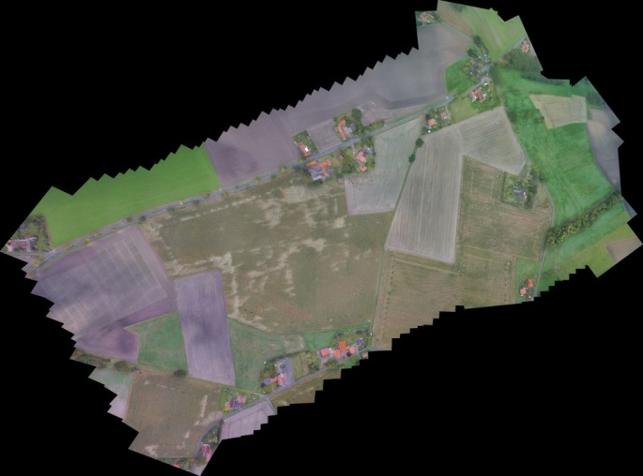 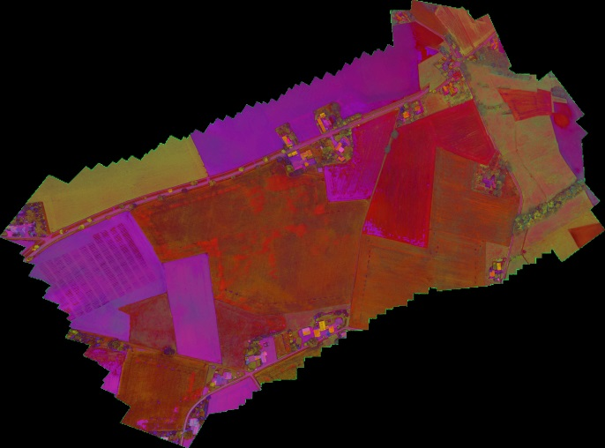

Original Stitched Image of Field and stuff HSV Version of Stitched Field Image

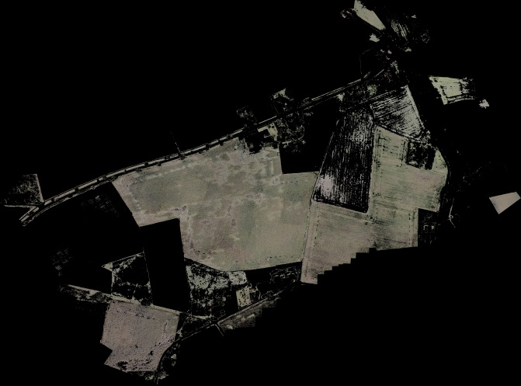 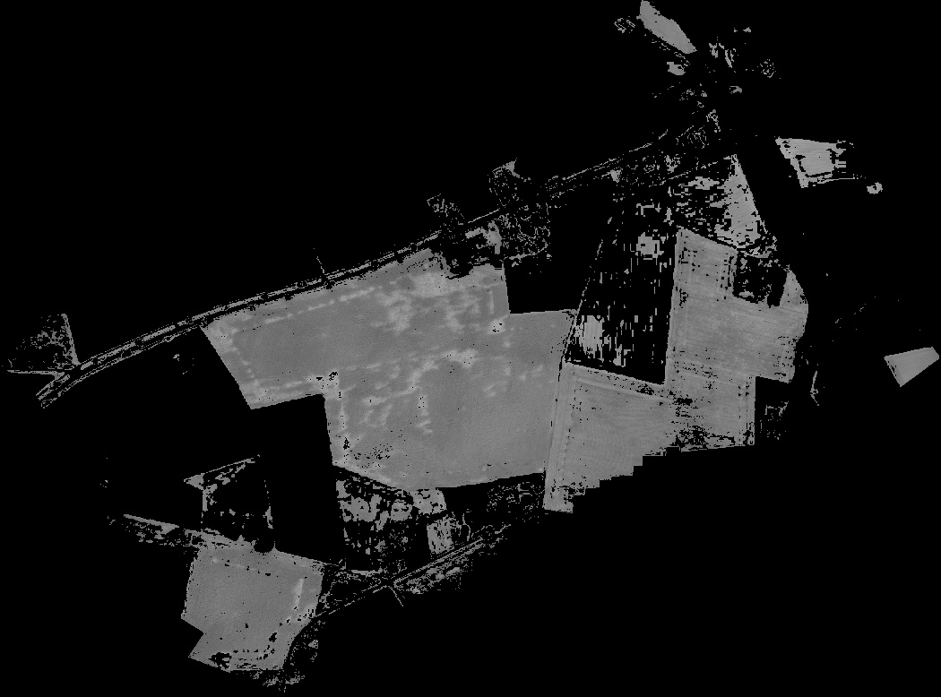

Cropped Image of the fields Grayscale Image of the fields

 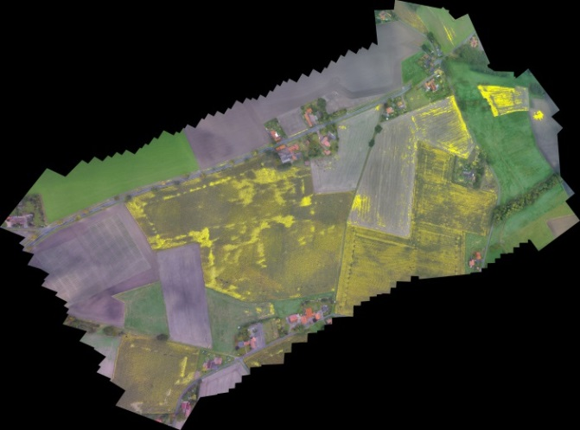

Binary image of bad parts of field Highlighted bad parts of field on the original image

**Code:**

/*

*Author: Avery Berchek

*Date: 11/15/14

*Name: Final Crop Analysis

*Description: This program analyzes a stitched image and outputs an image that shows where

*there are spots in a crop field that need to be checked up on.

*/

#include "opencv2/highgui/highgui.hpp"

#include "opencv2/imgproc/imgproc.hpp"

#include <iostream>

#include <stdio.h>

#include <stdlib.h>

using namespace cv;

using namespace std;

Mat src; Mat src_hsv; Mat threshold_output; Mat binary_image; Mat cropped; Mat src_black; Mat original; Mat display; Mat binary;

String file_image = "../largeStitch.jpg";

int percent = 0;

int thresh = 100;

int max_thresh = 255;

int HL = 0;

int HH = 255;

int SL = 0;

int SH = 255;

int VL = 0;

int VH = 255;

void call(int, void*)

{

//turns the pixel values that are within the hsv ranges to white, then displays them.

inRange(src_hsv, Scalar(HL, SL, VL), Scalar(HH, SH, VH), threshold_output);

namedWindow("output");

imshow("output", threshold_output);

}

Mat filter(Mat b)

{

GaussianBlur(b, b, Size(5, 5), 0, 0);

return b;

}

void crop()

{

binary_image = threshold_output; //binary image is equal to the binary matrix shown of the isolated field

original = imread(file_image, CV_LOAD_IMAGE_UNCHANGED); //retrieves the original stitched image

//original = filter(original); //Apply Gaussian Filter to image to reduce noise

threshold(src, src_black, 255, 255, THRESH_BINARY); //turns an image black

cropped = src_black; // sets the cropped matrix equal to that black image in order to have a clear backround.

double imSize = src.rows*src.cols;

for (int i = 0; i < src.rows; i++) // runs through the rows of the source image

{

for (int j = 0; j < src.cols; j++) // runs through the columns of the source image

{

if (binary_image.at<uchar>(i, j) > 250) //if the pixel value at i, j is white then...

{

//set the cropped pixel at (i, j) equal to the original image pixel at that point

cropped.at<Vec3b>(i, j)[0] = original.at<Vec3b>(i, j)[0];

cropped.at<Vec3b>(i, j)[1] = original.at<Vec3b>(i, j)[1];

cropped.at<Vec3b>(i, j)[2] = original.at<Vec3b>(i, j)[2];

}

}

percent = ((i*src.cols) / imSize) *100;

cout << percent;

cout << " Cropping (Step 1 of 4)" << endl;

}

//writes that cropped image to the hard drive

imwrite("../../../finalImage.jpg", cropped);

}

double calcThresh(Mat m){ //calculates the threshold.

double add = 0;

int size = 0;

double mSize = m.rows*m.cols;

for (int i = 0; i < m.rows; i++) // runs through the rows in the matrix

{

for (int j = 0; j < m.cols; j++) // runs through the columns in the matrix

{

if (binary_image.at<uchar>(i, j) > 1) //if the pixel is anything but black then...

{

size++; //adds up the total pixels that are not black

}

}

percent = ((i*m.cols) / mSize) * 100;

cout << percent;

cout << " Calculating Threshold (Step 2 of 4)" << endl;

}

double avg = 0;

add = sum(m)[0]; //a function made by opencv that sums up all the matrix values in a matrix.

avg = add / size; // finds the average by dividing the sum by the size.

return avg; //returns the average

}

void analyze()

{

Mat image; //creates matrices to store images in.

Mat GRAY;

Mat Binary;

double thresh;

//loads image located one directory up from this,

image = cropped; // sets the image equal to the cropped image from before.

cout << "Analyzing the cropped field for bad crops (Step 3 of 4)" << endl;

cvtColor(image, GRAY, COLOR_BGR2GRAY); //converts image from bgr values to Grayscale values.

thresh = calcThresh(GRAY); //calculates the threshold for the grayscale image.

thresh += (thresh*0.15); // adds 3/20 of its value to itself to filter out a little bit more noise.

threshold(GRAY, Binary, thresh, 255, THRESH_BINARY);//sets the treshold to the value of the trackbar.

//write images to the hard drive.

imwrite("../../../RegularImage.jpg", image); //after the escape key is pressed, images are saved

imwrite("../../../GrayImage.jpg", GRAY); //to the directory three directories up.

imwrite("../../../BinaryImage.jpg", Binary); //shows where the crop needs to be taken care of, white means it needs help.

}

void showBad()

{

binary = imread("../../../BinaryImage.jpg", CV_LOAD_IMAGE_UNCHANGED); //reads the binary image created by the analyze function

display = imread(file_image, CV_LOAD_IMAGE_UNCHANGED); //reads the original image

double bSize = binary.rows*binary.cols;

for (int i = 0; i < binary.rows; i++) //run through rows of image

{

for (int j = 0; j < binary.cols; j++) //run through columns of image

{

if (binary.at<uchar>(i, j) > 250) //if the pixel at position (i, j) is white then...

{

display.at<Vec3b>(i, j)[0] = 0; //... changes the pixel on the original image

display.at<Vec3b>(i, j)[1] = 255; // to yellow to make it easier to notice.

display.at<Vec3b>(i, j)[2] = 255;

}

}

percent = ((i*binary.cols) / bSize) * 100;

cout << percent;

cout << " Highlighting Bad Parts (Step 4 of 4)" << endl;

}

imwrite("../../../Final Image.jpg", display);

}

int main(int argc, char** argv)

{

/// Load source image and convert it to gray

src = imread(file_image, CV_LOAD_IMAGE_UNCHANGED);

cout << "converting to HSV" << endl;

/// Convert image to HSV

cvtColor(src, src_hsv, CV_BGR2HSV);

/// Create Window

//namedWindow("HSV TrackBars", CV_WINDOW_AUTOSIZE);

//imshow("HSV TrackBars", src);

//Create Trackbars for different HSV values

//createTrackbar("H Low", "HSV TrackBars", &HL, HH, call);

//createTrackbar("H High", "HSV TrackBars", &HH, HH, call);

//createTrackbar("S Low", "HSV TrackBars", &SL, SH, call);

//createTrackbar("S High", "HSV TrackBars", &SH, SH, call);

//createTrackbar("V Low", "HSV TrackBars", &VL, SH, call);

//createTrackbar("V High", "HSV TrackBars", &VH, SH, call);

//call(0, 0); //calls the call function in orer to update the output.

HL = 2;

HH = 42;

SL = 17;

SH = 69;

VL = 94;

VH = 178;

cout << "Isolating the binary part." << endl;

// turns the values in the range to white.

inRange(src_hsv, Scalar(HL, SL, VL), Scalar(HH, SH, VH), threshold_output);

//writes the binary image to the hard drive

imwrite("../../../BinaryImage.jpg", threshold_output);

crop(); //crops the image to where it is just the field

analyze(); //analyzes the cropped image for dead spots

showBad(); //turns the bad spots on the original image to yellow in order to easily view it

}